Curricular Complexity Analysis

The objective of this study is to explore UCLA undergraduate course curriculum and better understand how curricular complexity correlates with student academic outcomes such as on-time graduation and time-to-degree. A curriculum’s structural complexity is defined by the relationship between the courses in the curriculum. It is a metric correlated to how complex the curriculum’s graph is. Curricula with courses that have many prerequisite relationships will have a greater structural complexity. Structural curricular complexity also correlates with efficiency, the greater the efficiency of a curriculum the greater the likelihood that students can matriculate through their major in a more timely manner, reducing time-to-degree. Below is an example from the University of New Mexico (<https://curricula.academicdashboards.org/>) where we can see a curriculum’s complexity is a function of the complexity of each individual required course contained within the curriculum (major requirements) as well as the interrelationships or dependencies among the required courses.

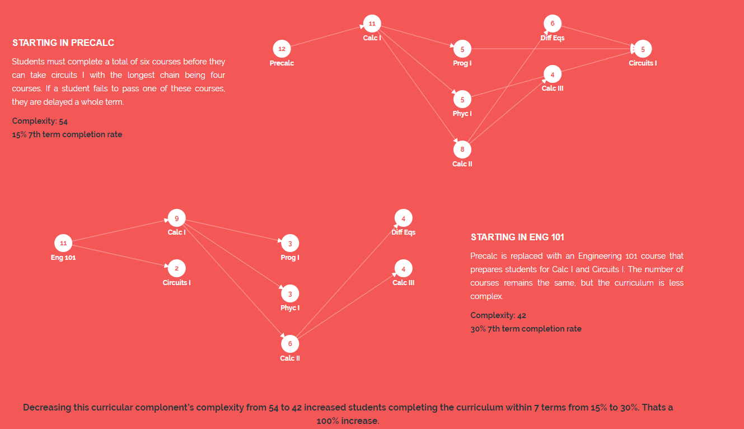

Data from three sources will be needed to complete this project. First, we will provide course prerequisite data in table format which is extracted from the Registrar’s database but it might need further cleanup and/or parsing to be able to provide improved utility for calculating course complexity. The same data in text format with detailed course descriptions can also be found at the UCLA course catalog website (<http://catalog.registrar.ucla.edu/ucla-catalog19-20-270.html>). Take CHEM 110A as an example below, its prerequisite information is shown in text on the course catalog website. But the data we provide is processed through combining multiple database tables into one.





+

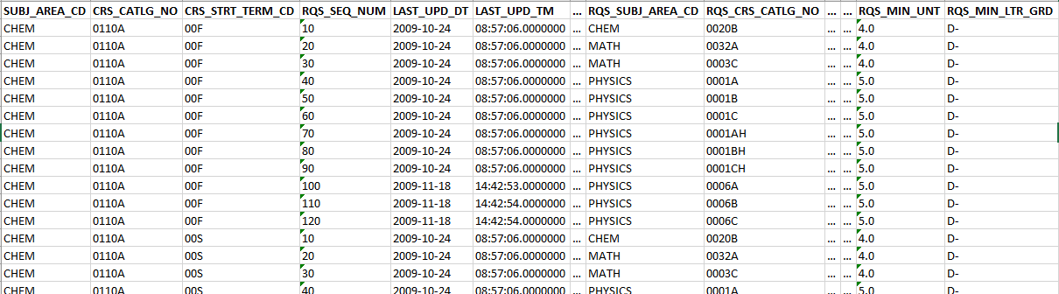

+

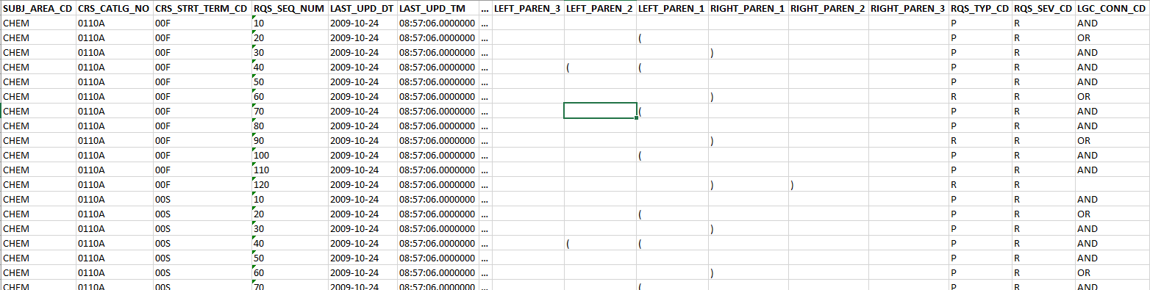

=

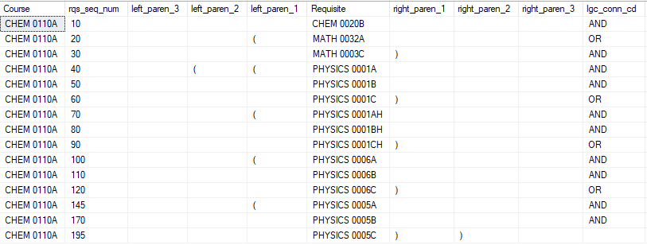

With structured course prerequisite data, complexity metrics for each course can be constructed. There are various complexity metrics documented in the existing literature, and here are just a few examples. In-degree is the total number of requisites for a given course. Courses with high in-degree are difficult to reach as every requirement must be satisfied prior to enrolling in the course. Out-degree is the number of courses that require the given course as an immediate (first level) requisite. Courses with high out-degree are critical in the sense that success in the course enables students to enroll in many other courses. Blocking factor is the number of all courses (n level) that are blocked through prerequisite relationships by the given course. Delay factor is the number of courses on the longest prerequisite path that intersects with a given list of major requirements.

The second piece of data required for this analysis is the major requirements. It’s needed because we want to extend from course complexity to curricular complexity – to compute complexity metrics for each course and for each major. At the major level, the goal is to compute a set of metrics for faculty and department administrators to easily assess the complexity of their curricula and provide useful insights for curriculum committees that are considering changes to programs. The challenge is that major requirement data is currently not available in table form and therefore cannot be accessed programmatically to map a curriculum. Such data can only be found in text format on the course catalog website (<http://catalog.registrar.ucla.edu/ucla-catalog19-20-4.html>), so we suggest you take 10-20 majors from a variety of disciplines as a sample for this pilot study and convert their major requirement information from the webpage into structured dataset. Below is an example of pre-major and major requirements for Physics BS.







Last but not least, we will provide data of student outcome metrics such as average time-to-degree that are coming from APB database. You will need to link the calculated complexity metrics to outcome metrics to measure the role that the structure of a curriculum plays in student academic success and tell the amount of variance, if any, these complexity metrics are explaining. The findings of this project can potentially provide useful recommendations for streamlining or optimizing course curricula, set targeted increases in course supply to better meet student demand, and lower time-to-degree for those student groups previously impacted by inefficiently structured major pathways.

In terms of the data provided the main research questions:

* Can we utilize the course prerequisite data to compute a set of course complexity scores for each course?
* Can we utilize both course prerequisite and major requirement data to compute a set of curricular complexity scores for each of the selected majors, so we can easily assess and compare across majors?
* What is the role that the structure of a curriculum plays in student academic success and what is the amount of variance, if any, these complexity metrics are explaining?

Secondary questions or areas of consideration:

* Based on the use case of this project, can you provide some suggestions on how we should structure major requirement data into tables so that it can be of use for our future needs?

Useful background materials/readings:

<https://www.asee.org/file_server/papers/attachment/file/0004/3560/CurricularEfficiency-Final.pdf>

<https://completega.org/sites/default/files/resources/UGA-Student-Flows-Article.pdf>